集美大学计算机工程学院实验报告

课程名称：Java程序设计 | 班级：软件1912 | 实验成绩：
指导教师：李 旺 | 姓名：施嘉宏
实验项目名称：Java Web入门 | 学号：201921122044 | 上机实践日期：
实验项目编号：10 | 组号： | 上机实践时间： 2 学时

一、目的
了解基本的Java Web编程。
二、实验内容与设计思想
1．实验内容
1）HTML
<!DOCTYPE html>
<html lang="en">
<head>
<meta charset="UTF-8">
<title>my first html</title>
<link rel="stylesheet" type="text/css" href="index.css">
<script type="text/javascript" src="index.js"></script>
</head>
<body>
<script>
window.onload = function () {
var clock = document.getElementsByClassName("clock")[0];
var clockHeight = clock.offsetTop;
window.onscroll = function () {
fixedDom(clock, clockHeight, 0);
}
}
</script>
<canvas id="snow-canvas"></canvas>
<div class="title-div">
<p>Hello HTML</p>
<img src="http://s2.hdslb.com/bfs/static/blive/blfe-dynamic-web/static/img/background.bc725153.png"/>
</div>
<div class="line-img-div">
<img style="width: 100%"
src="https://cdn.jsdelivr.net/gh/BNDong/Cnblogs-Theme-SimpleMemory@master/img/webp/nothome_top_bg.webp"/>
</div>
<div class="passage-container">
<h1 style="margin-bottom: 2em">
<center>人民日报节选</center>
</h1>
<script>createPassage()</script>
</div>
<div class="clock">
<div id="clock">local time</div>
<div><center><button onclick="drawSnowCanvas()"><b>开关雪花特效</b></button></center></div>
<script>startClock()</script>
</div>
<div class="top-tap">
<button onclick="jumpToTop(this)" style="border: none; background: rgba(255,255,255,0); outline: none;">
<img src="http://s2.hdslb.com/bfs/static/blive/blfe-dynamic-web/static/img/rocket_top.bcc748c3.png"/>
</button>
</div>
</body>
</html>
2) css
.title-div{
text-align: center;
font-size: 60px;
color: brown;
}
.title-div img {
position: fixed;
top: 0;
left: 0;
z-index: -2;
}
#snow-canvas{
position: fixed;
top: 0;
left: 0;
}
.clock{
border: 5px solid #ffcd32;
border-radius: 10px;
padding: 5px;
color: white;
font-size: 30px;
font-weight: bold;
cursor: default;
position: absolute;
top: 236px;
right: 5vw;
user-select: none;
}
.top-tap{
position: fixed;
bottom: 2vh;
right: 10px;
}
.top-tap button:hover{
cursor: pointer;
filter: brightness(105%);
padding-bottom: 10px;
}
.line-img-div{
width: 100vw;
height: 40vh;
position: absolute;
top: 0;
left: 0;
z-index: -1;
margin-bottom: 10px;
overflow: hidden;
box-shadow: 0px 2px 5px #888888;
}
.line-img-div img{
position: absolute;
bottom: -100%;
left: 0;
}
.passage-container{
width: 50vw;
background: white;
margin: 10vh auto;
padding: 3em;
border-radius: 5px;
box-shadow: 2px 2px 5px #888888;
}
.passage-container>p{
font-family: "宋体";
font-size: 18px;
font-weight: 400;
text-indent: 2em;
letter-spacing: 0.1em;
line-height: 28px;
}
3) js
function jumpToTop(sender) {
console.log("click top");
moveScroll(0, 300);
}
function createPassage() {
var str = “…此处省略文章文本”;
var list = str.split('\n');
for (i = 0; i < list.length; i++) {
var newEle = document.createElement("p");
var newText = document.createTextNode(list[i]);
newEle.appendChild(newText);
var element = document.getElementsByClassName("passage-container")[0];
//console.log(element);
element.appendChild(newEle); //追加的元素在div容器内
}
}
function startClock() {
setLocalTIme();
setInterval(setLocalTIme, 1000);
}
function Point(x,y) {
return {
x: x,
y: y,
}
}
function Dimension(width, height) {
return {
width: width,
height: height,
}
}
function getRandomNum(max, min) {
return Math.floor(Math.random()*(max-min+1) + min);
}
function drawSnowCanvas() {
var canvas=document.getElementById("snow-canvas");
canvas.height = window.innerHeight;
canvas.width = window.innerWidth;
var g=canvas.getContext("2d");
var image = new Image();
var p = new Point(0,0);
var size = new Dimension(100,100);
image.src="../../img/flake.png";
if(typeof(snowTimer) == "undefined") {
snowTimer = setInterval(function () {
g.clearRect(0,0, canvas.width, canvas.height);
var count = getRandomNum(10,20);
for (i=0; i<count; i++) {
p.x = getRandomNum(0, canvas.width);
p.y = getRandomNum(0, canvas.height);
size.width = getRandomNum(10,100);
size.height = size.width;
g.drawImage(image, p.x, p.y, size.width, size.height);
}
},1000);
} else {
clearInterval(snowTimer);
g.clearRect(0,0, canvas.width, canvas.height);
snowTimer = undefined;
}
}
function fixedDom(dom, height, fixedTop) {
var scrollTop = document.documentElement.scrollTop || document.body.scrollTop;
if(scrollTop > height){
dom.style.position = "fixed";
dom.style.top = fixedTop + "px";
} else {
dom.style.position = "absolute";
dom.style.top = height + "px";
}
}
function setLocalTIme() {
var obj = document.getElementById("clock");
var data = new Date();
obj.innerText = data.toLocaleTimeString();
if (data.getMinutes() === 0 && data.getSeconds() === 0) {
var color = obj.style.color;
var size = obj.style.fontSize;
obj.style.color = "red";
obj.style.fontSize = "35px"
setTimeout(() => {
obj.style.color = color;
obj.style.fontSize = size;
}, 15000);
}
}
function moveScroll(target, time) {
var start = document.documentElement.scrollTop || document.body.scrollTop;
var dis = target - start;
var count = Math.floor(time / 15);
var n = 0;
if (typeof (timer) != "undefined") clearInterval(timer);
timer = setInterval(function () {
n++;
bFlag = false;
document.documentElement.scrollTop = start + dis * n / count;
document.body.scrollTop = start + dis * n / count;
if (n == count) {
clearInterval(timer);
}
}, 15);
}

三、实验使用环境
Chrome

四、实验步骤和调试过程
1．实验结果
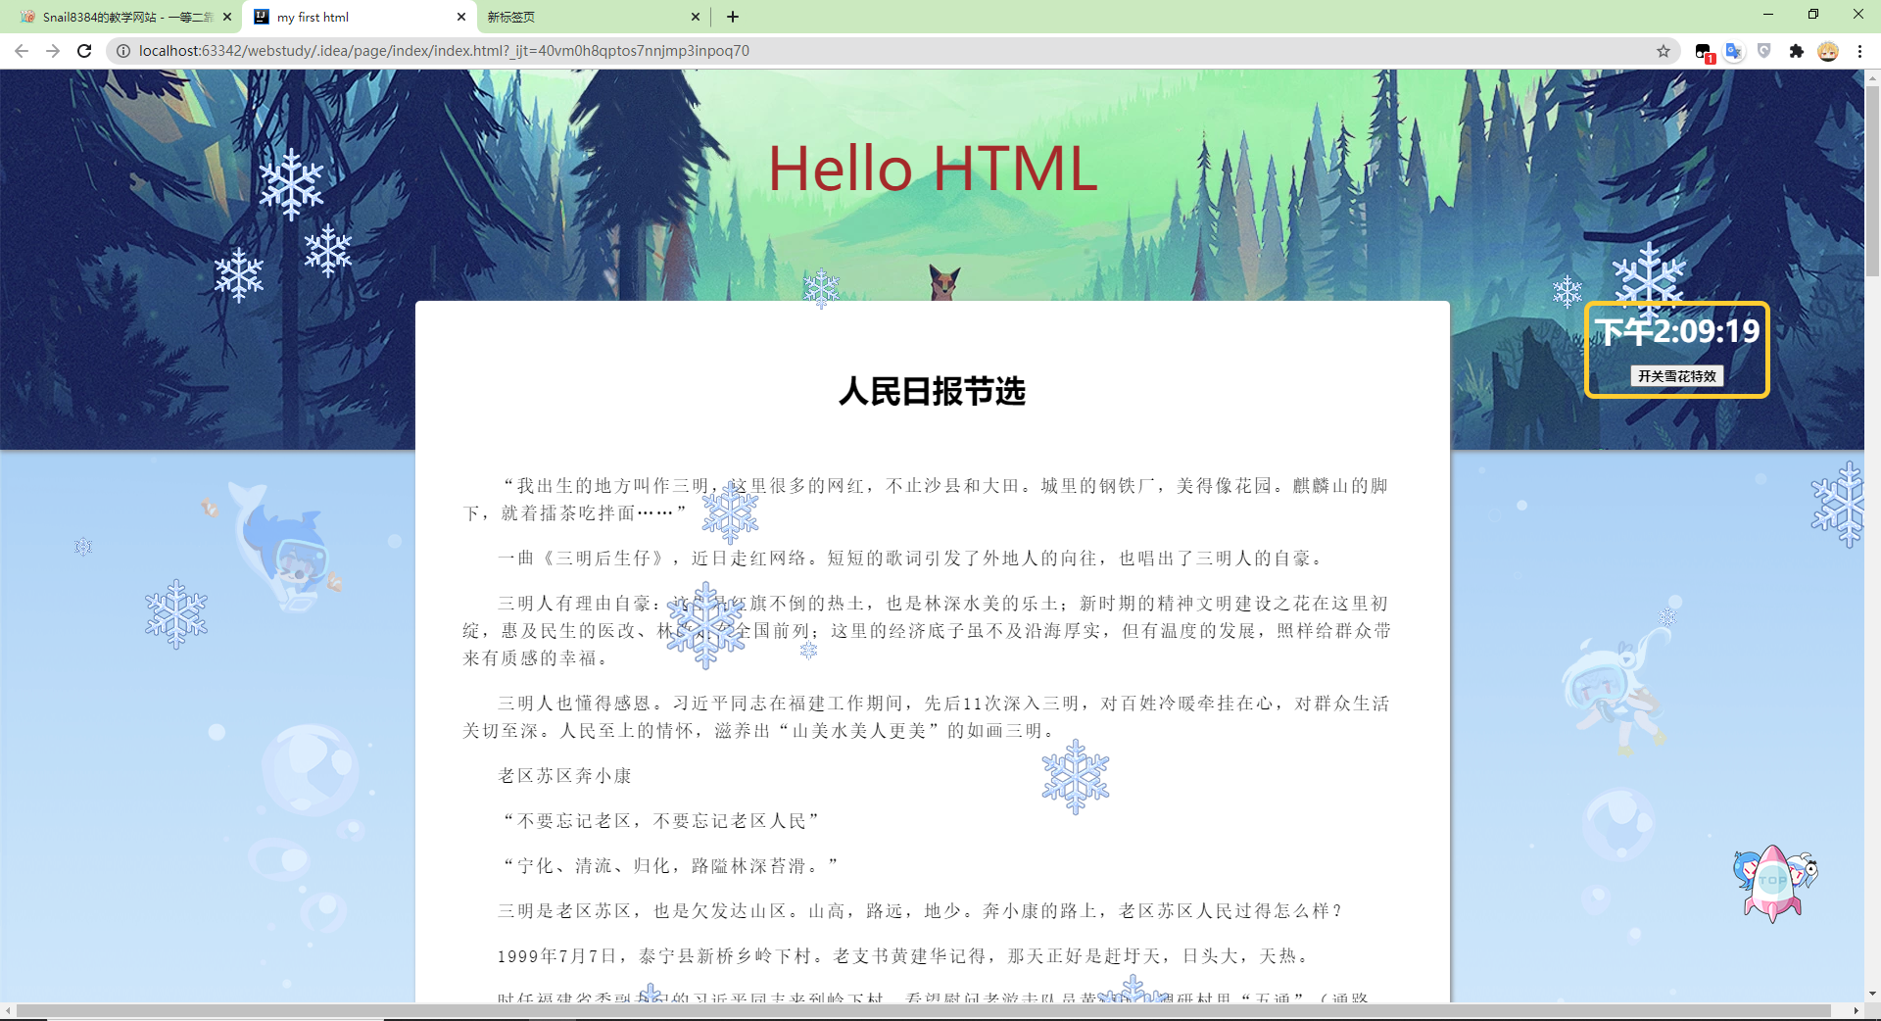
五、实验小结
1．实验中遇到的问题及解决过程
问题1：canvas宽高自适应
解决：在js内用window的innerHeight/innerWidth初始化宽高
问题2：载入时执行脚本
解决：使用window.onLoad设置载入时执行的脚本
2．实验体会和收获。
初学web前端，很多知识仍未掌握，代码不够规范，还需要继续磨练和学习。
六、附录
图片资源来自网络
文章来自人民日报

